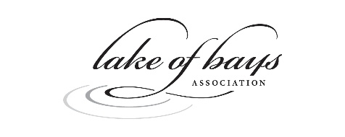
2026 Yearbook Advertising Insertion Order

COMPANY NAME – As you wish it to appear in the Advertisers Directory: Click or tap here to enter text.
NAME: Click or tap here to enter text.
Mailing address: Click or tap here to enter text.
E-mail: Click or tap here to enter text.
Telephone: Click or tap here to enter text.
Contact for ad approval if different from above: Click or tap here to enter text.
BOOKING DETAILS
Ad Size | Cost | HST | TOTAL
☐ Full Page | $1250 | $162.60 | $1412.50
☐ Full Page, Premium Placement | $1450 | $188.50 | $1638.50
☐ Half Page Vertical | $825 | $107.25 | $932.25
☐ Half Page Vertical, Premium Placement | $950 | $123.50 | $1073.50
☐ Half Page Horizontal | $825 | $107.25 | $932.25
☐ Quarter Page | $700 | $91 | $791.00
☐ Marketplace Single Square | $250 | $32.50 | $282.50
☐ Marketplace Double Square | $450 | $58.50 | $508.50

BILLING - Choose an item.

ARTWORK - Deadline for all ads and/or artwork is March 16, 2026. Choose an item.

AD MATERIAL REQUIREMENTS - Files saved as high-quality PDF, Adobe Illustrator or TIFFs with a resolution of 300 dpi. Send your ads and/or artwork to info@loba.ca; Subject: Lake of Bays Association Yearbook Advertising Artwork.

I agree to book ad space in the 2026 Lake of Bays Association yearbook, as indicated above.

Signature: Click or tap here to enter text. Date: Click or tap to enter a date.
Please return this completed form to Bryan Dearsley, Advertising Manager, bdearsley@live.ca or by mail to:
Lake of Bays Association, PO Box 8, Baysville ON, P0B 1A0

For Office Use Only: Click or tap here to enter text.

